React Blog Dashboard Hands On Exercise Solution
A Vite React dashboard displays the supplied four blogs and uses reusable components, hooks, memoization, and Redux Toolkit. The screenshots below show the source files and running output for each part.

Question 1 React Blog UI with Hooks

Part 1 React Project and Reusable Components Marks 1
The project contains Header, SearchBar, BlogCard, BlogList, and BlogStats components. The editor capture shows the project files and the App component imports.
VS Code Editor and Project Structure
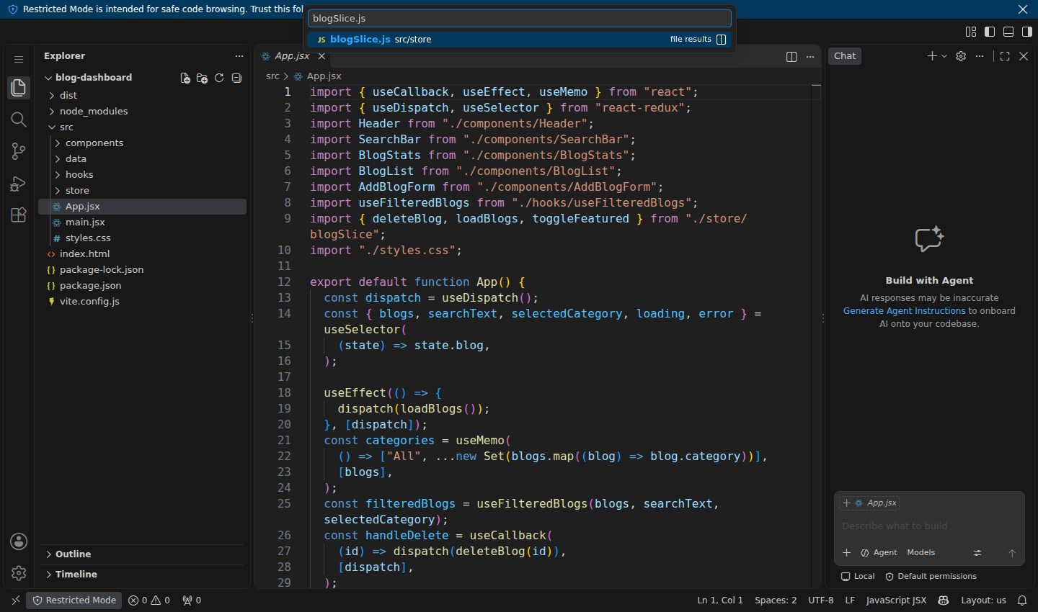
Header Component
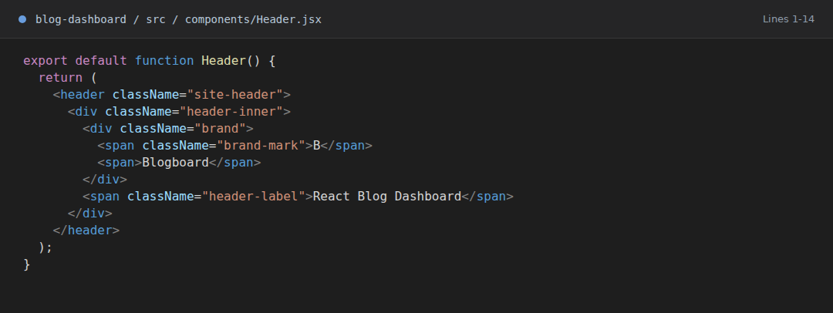
BlogList Component and map Rendering
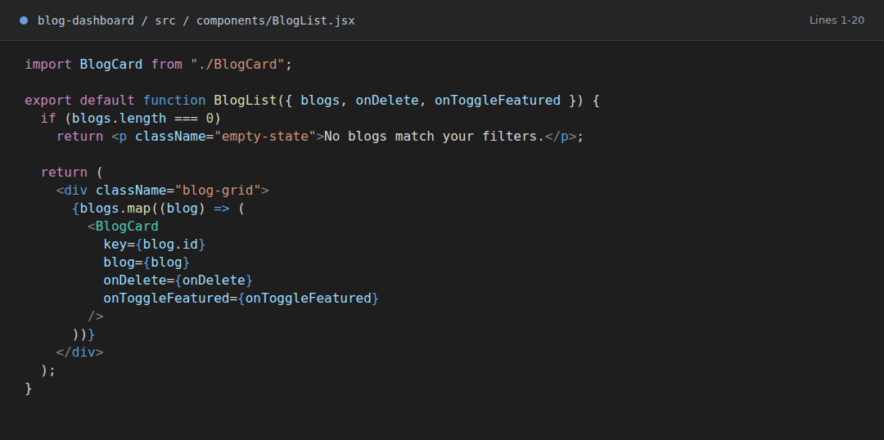
BlogStats Component
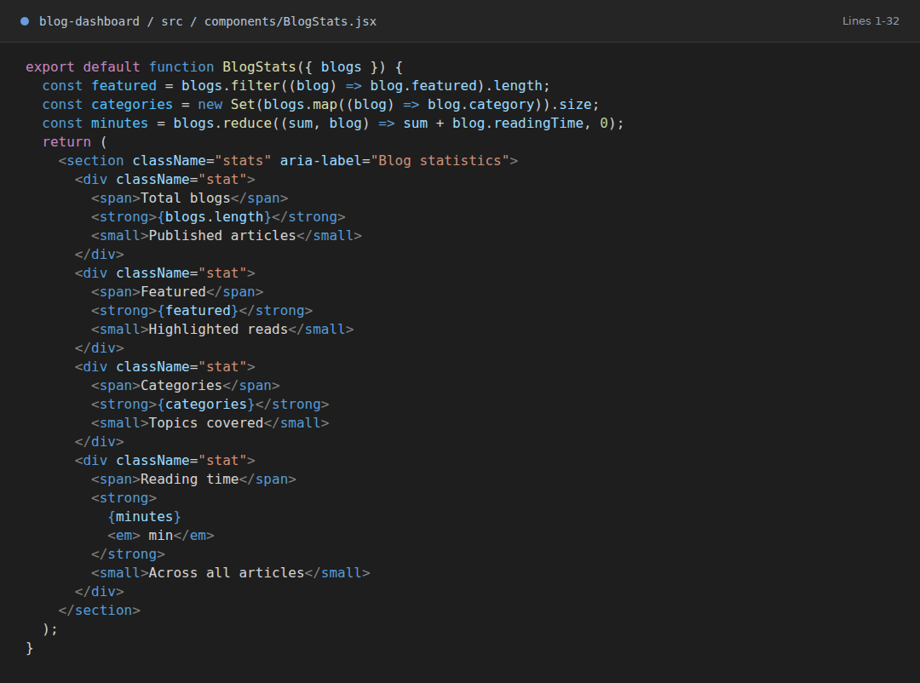

Part 2 Display the Supplied Blog Data Marks 1
The blog array contains the four specified records. BlogCard displays title, category, author, reading time, and featured status.
Initial Blog Array
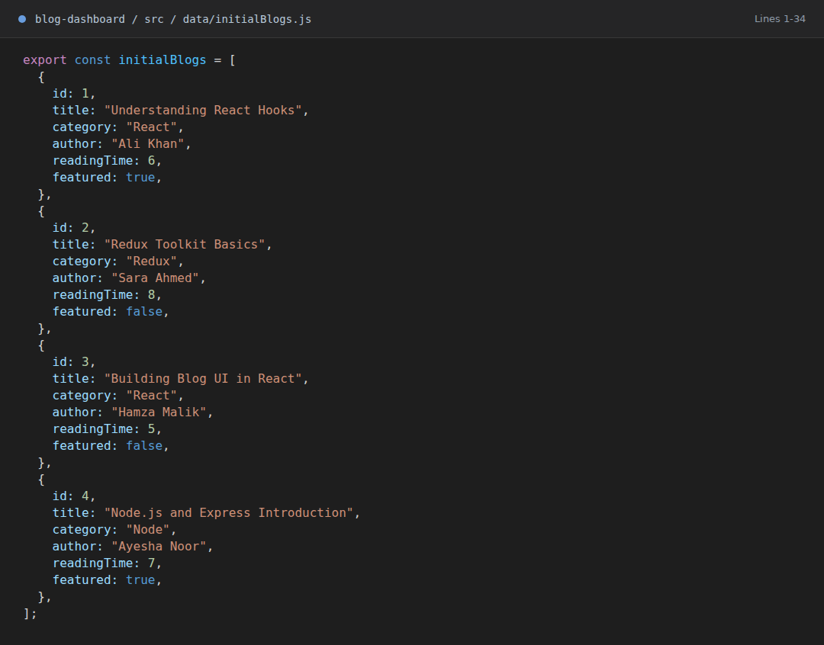
Reusable BlogCard Component
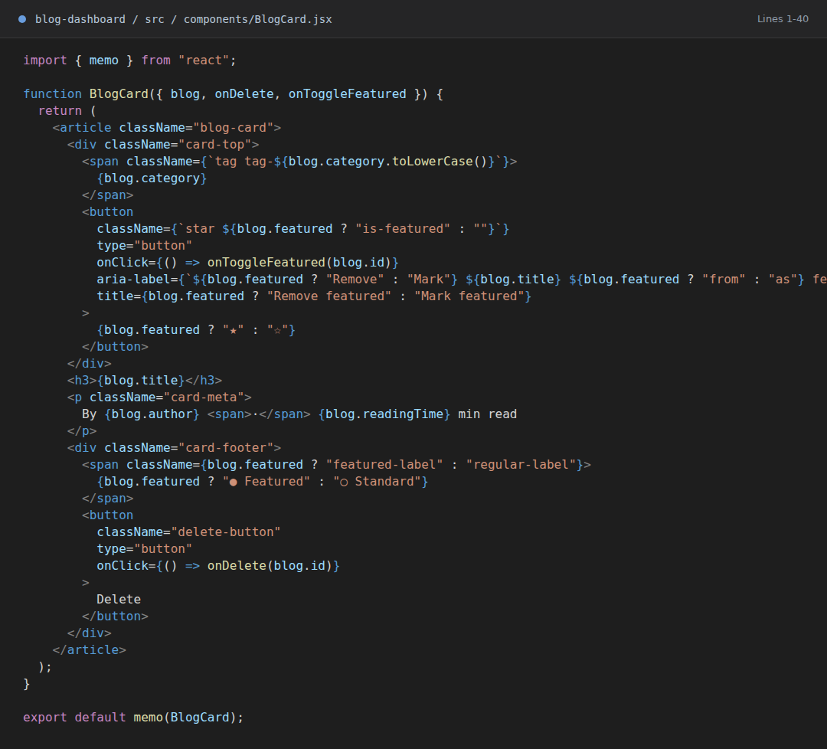
Browser Output with All Four Blogs
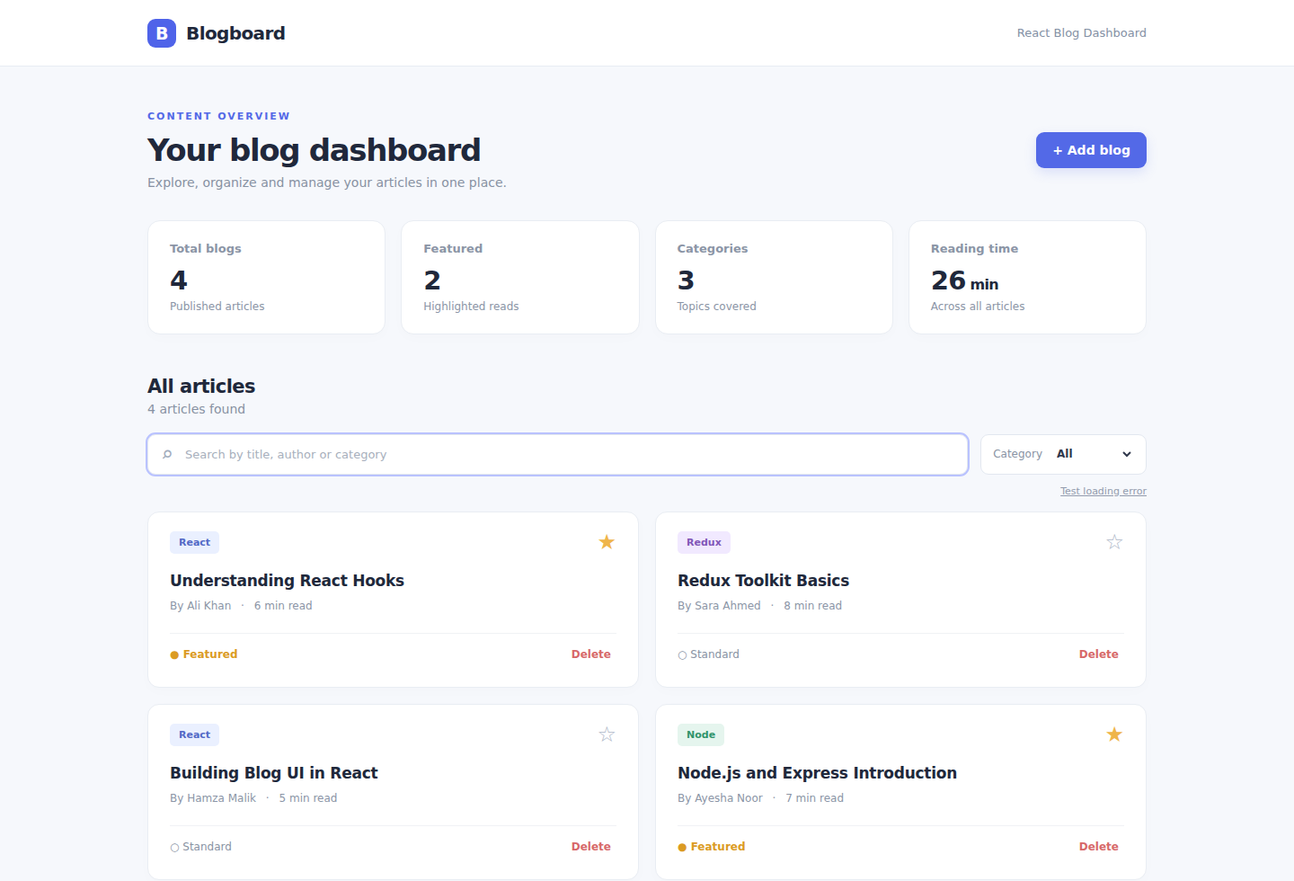

Part 3 Custom Hook and Memoized Filtering Marks 1.5
useFilteredBlogs uses useMemo and applies both search text and selected category. The two outputs demonstrate each filter.
useFilteredBlogs Custom Hook
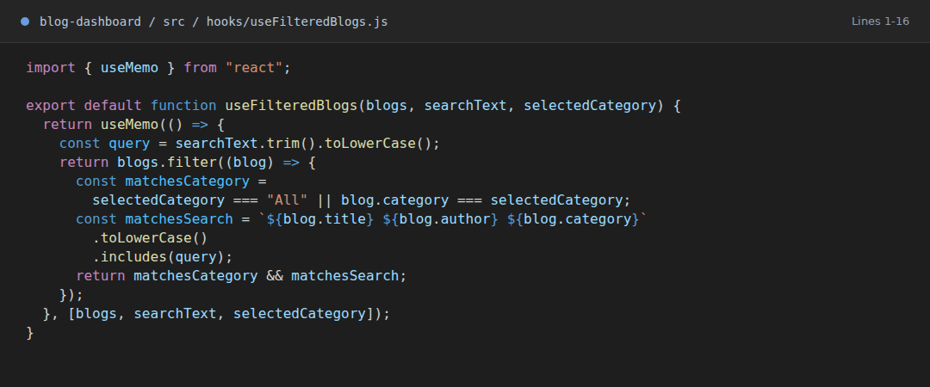
Browser Output after Searching for Redux
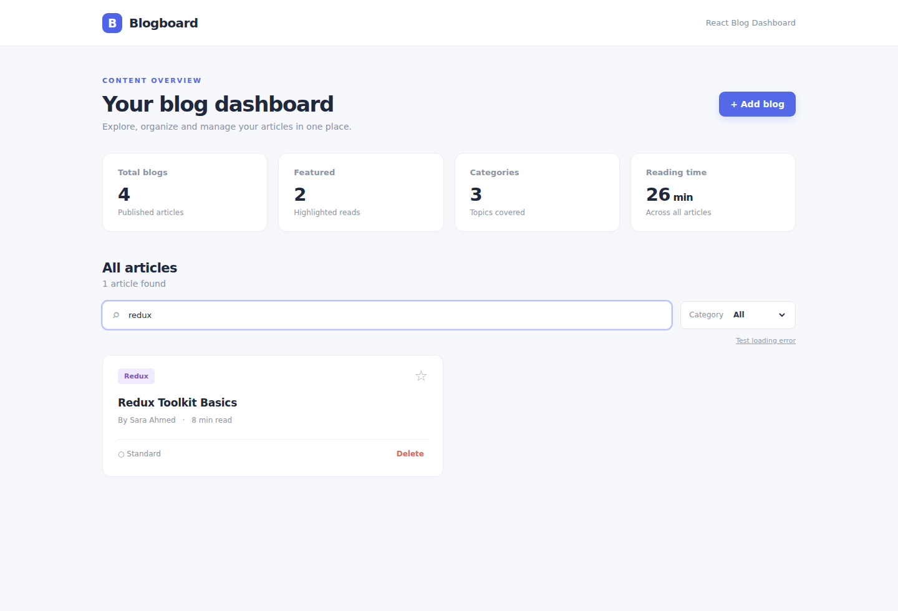
Browser Output after Selecting React
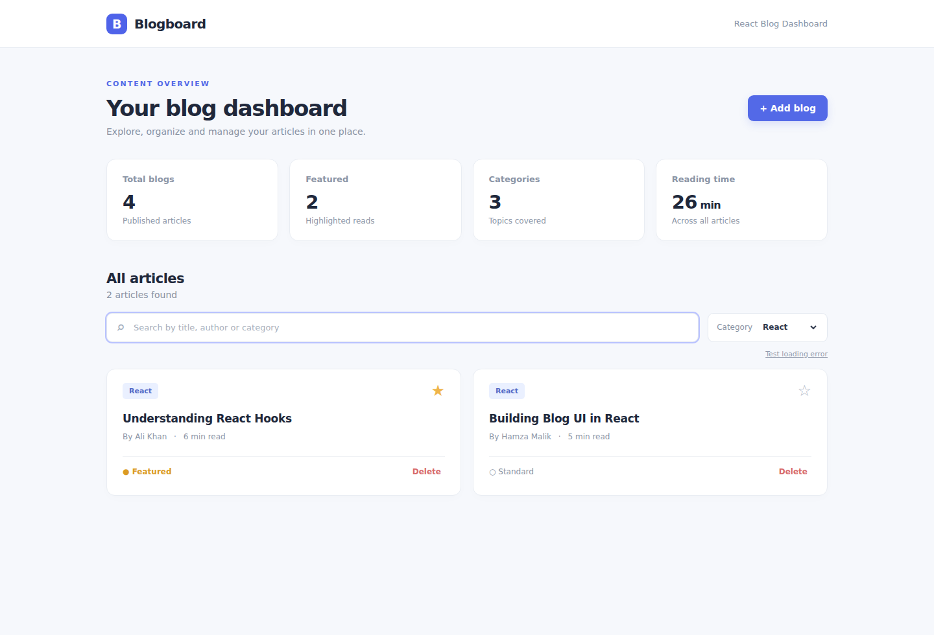

Part 4 Search Focus and Memoized Actions Marks 1
SearchBar focuses the input on mount with useRef. App supplies stable delete and favorite callbacks with useCallback. BlogCard is wrapped with React.memo.
SearchBar with useRef and Redux Actions
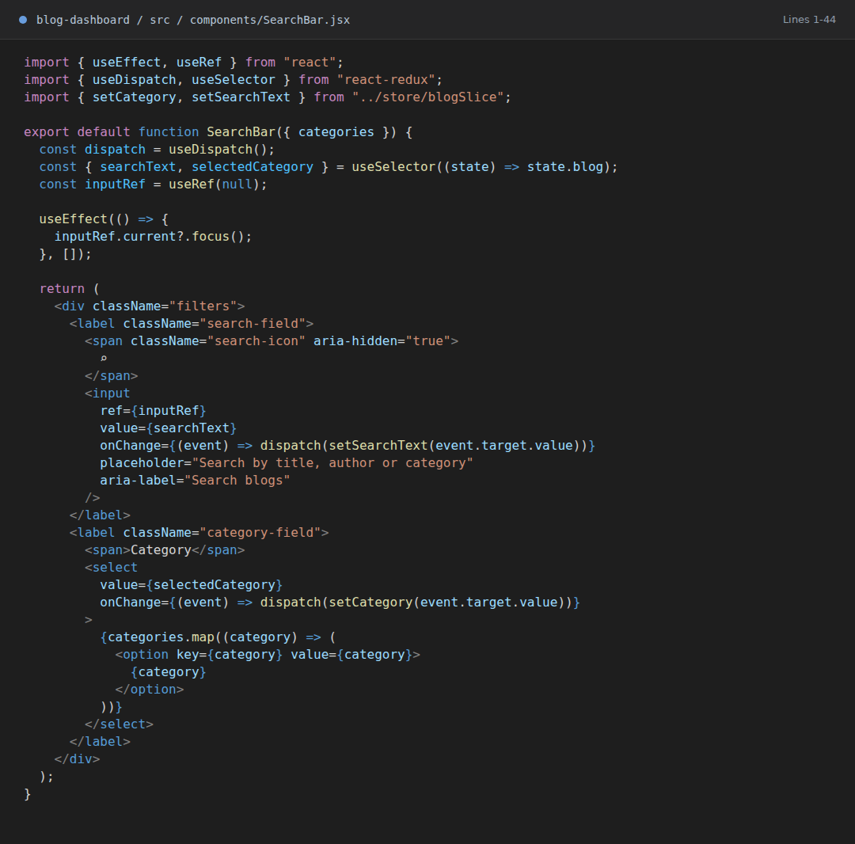
App Hooks and useCallback Actions
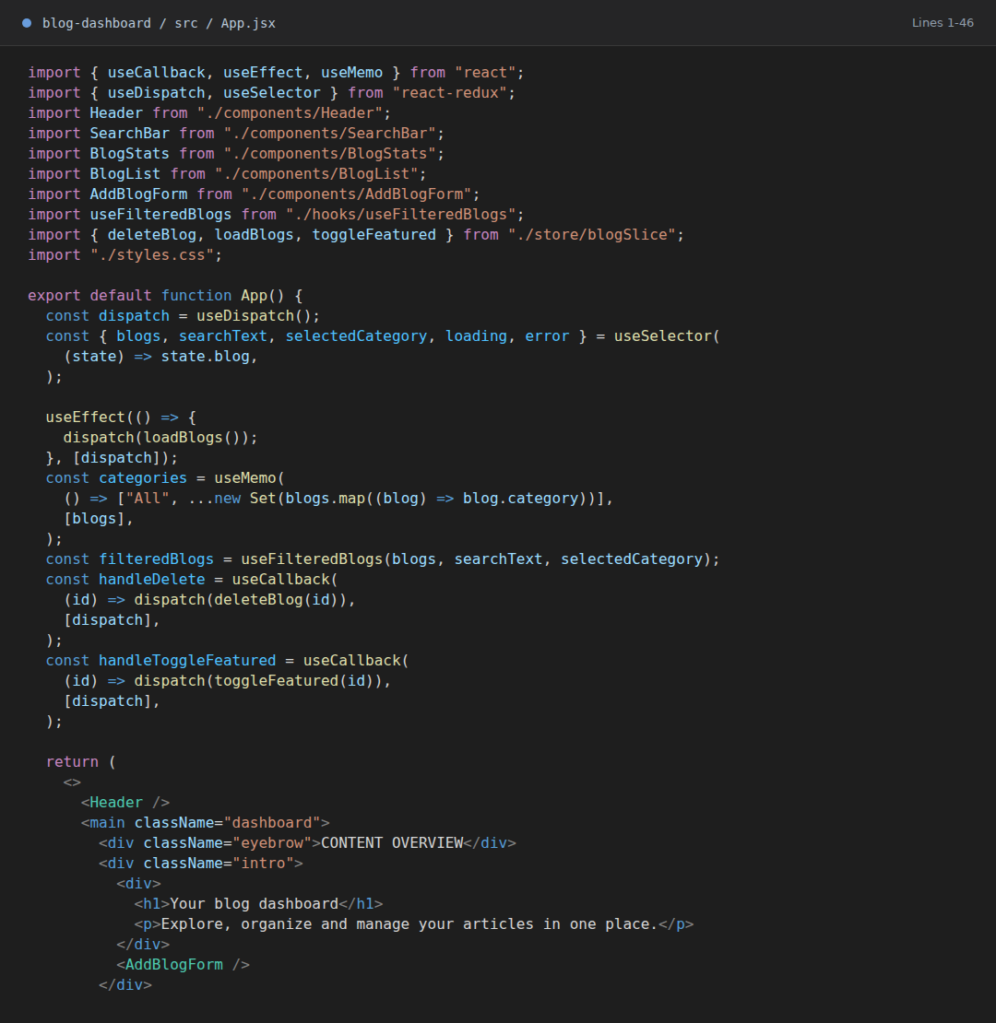
Browser Output after Toggling Featured
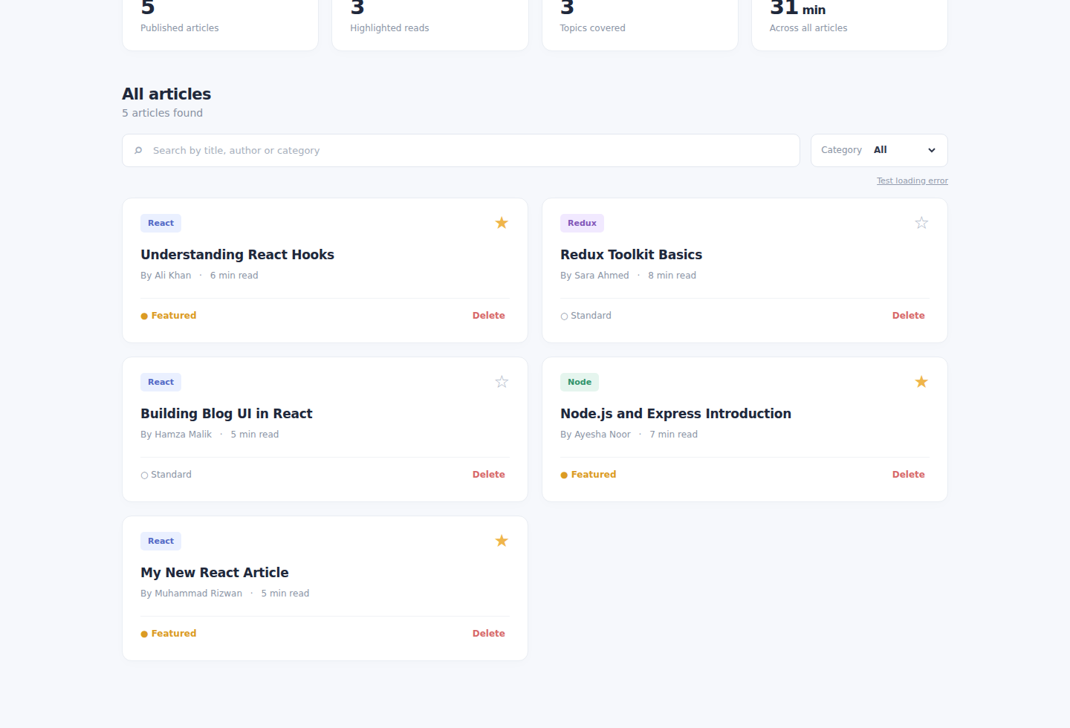

Part 5 Responsive Dashboard Styling Marks 0.5
CSS Grid arranges the statistic tiles and blog cards. Media queries change the layout for smaller screens.
Responsive CSS Rules
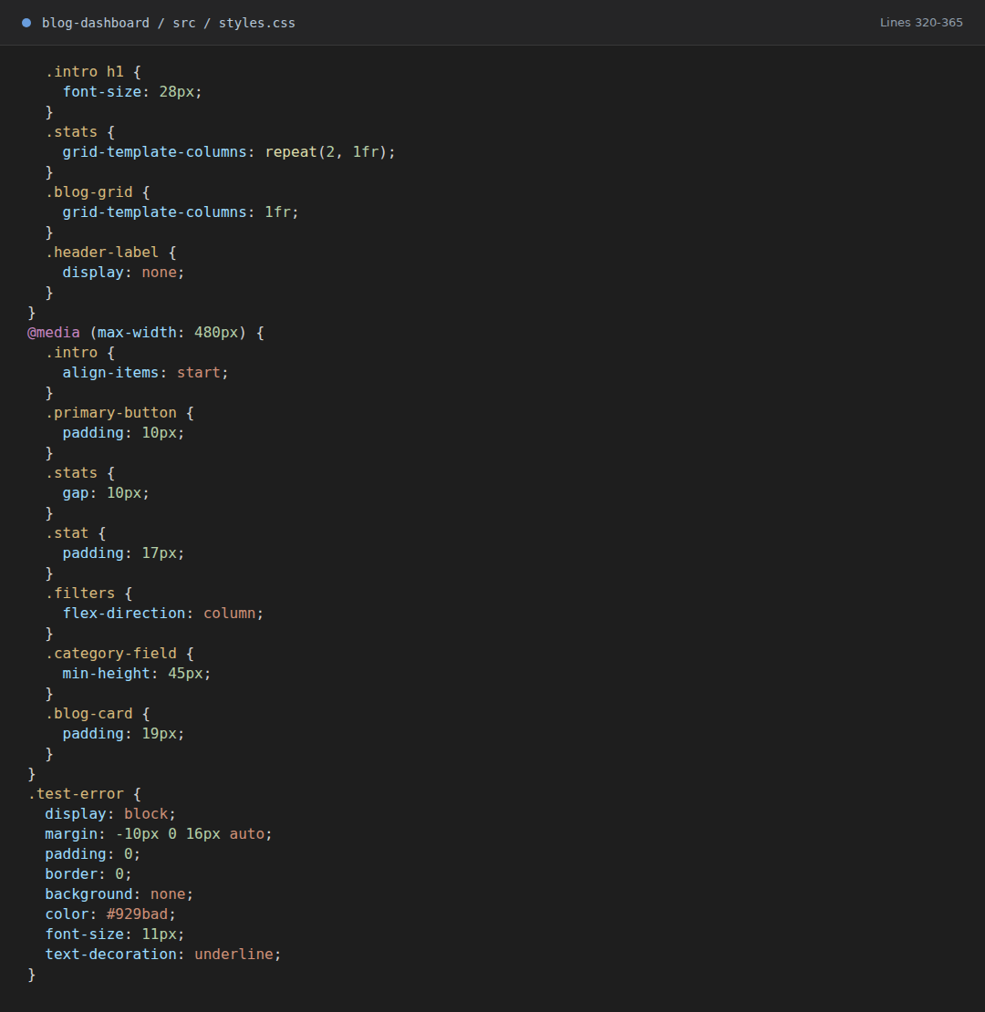
Mobile Browser Output
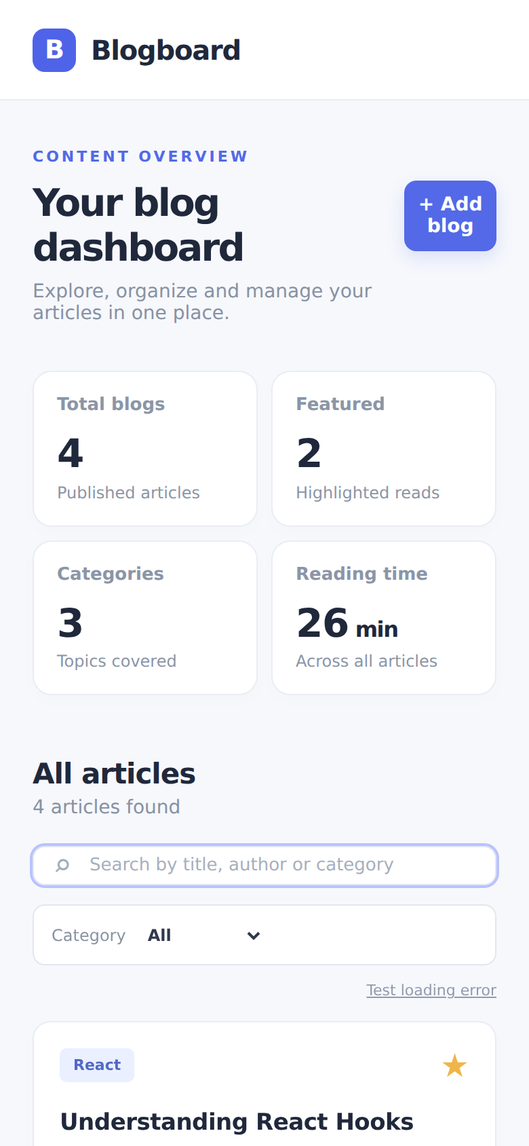

Question 2 Redux State Management for Blog Dashboard

Part 1 Redux Toolkit Store and Slice Marks 1
The Vite project installs @reduxjs/toolkit and react-redux. The store registers blogReducer and Provider makes it available to the component tree.
Project Dependencies and Vite Scripts
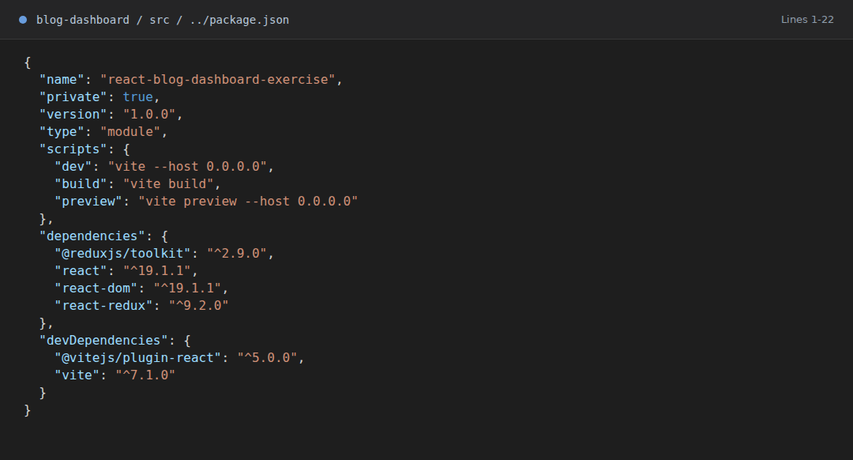
Redux Store Configuration
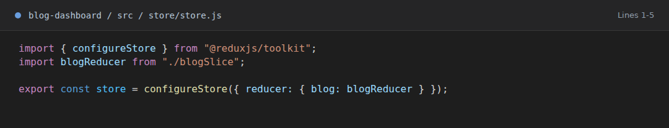
React Redux Provider in main.jsx
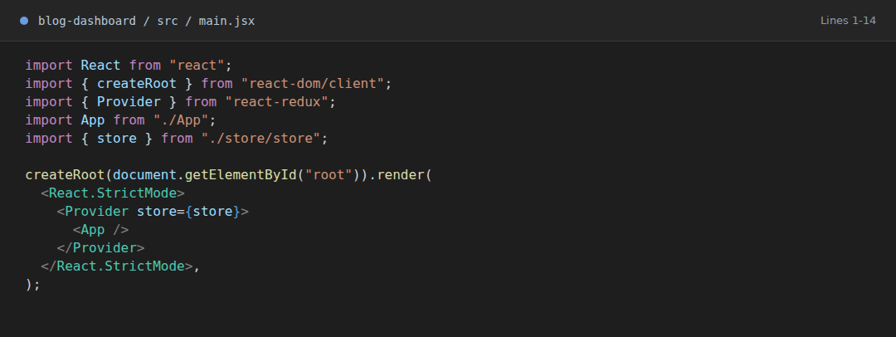

Part 2 Redux Blog and UI State Marks 1
blogSlice stores blogs, searchText, selectedCategory, loading, and error. The async request updates loading and error states.
Blog Slice Async Request and Initial State
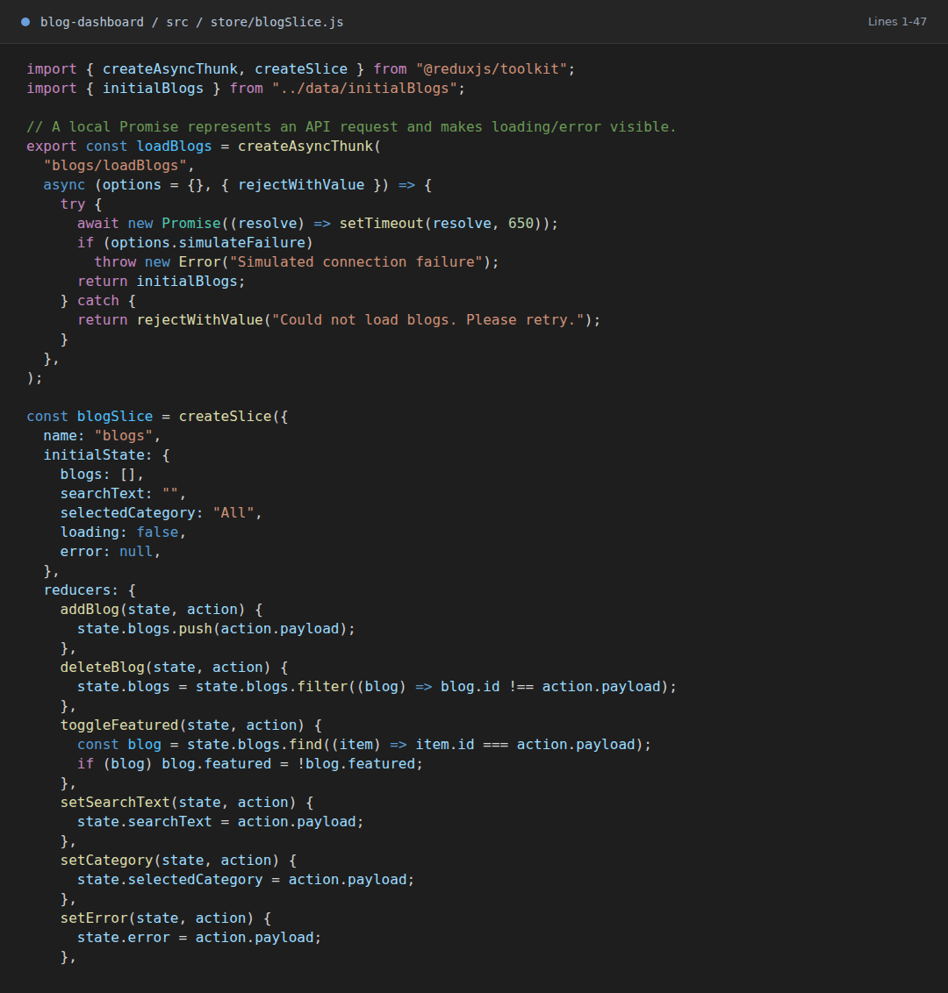

Part 3 Add Delete Toggle and Filter Reducers Marks 1.5
The slice provides addBlog, deleteBlog, toggleFeatured, setSearchText, and setCategory reducers. The add form dispatches a new blog, while card buttons dispatch favorite and delete actions.
Blog Slice Reducers and Async Cases
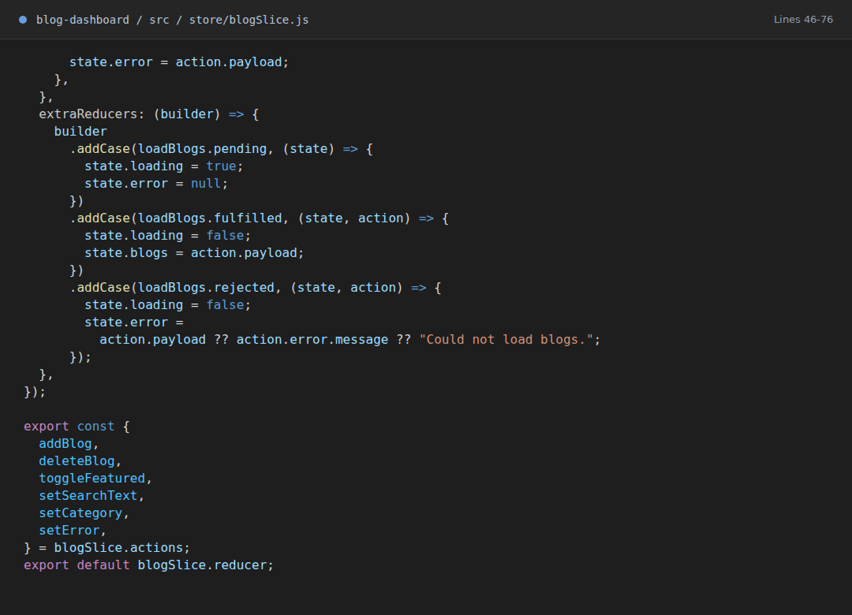
AddBlogForm Dispatching addBlog
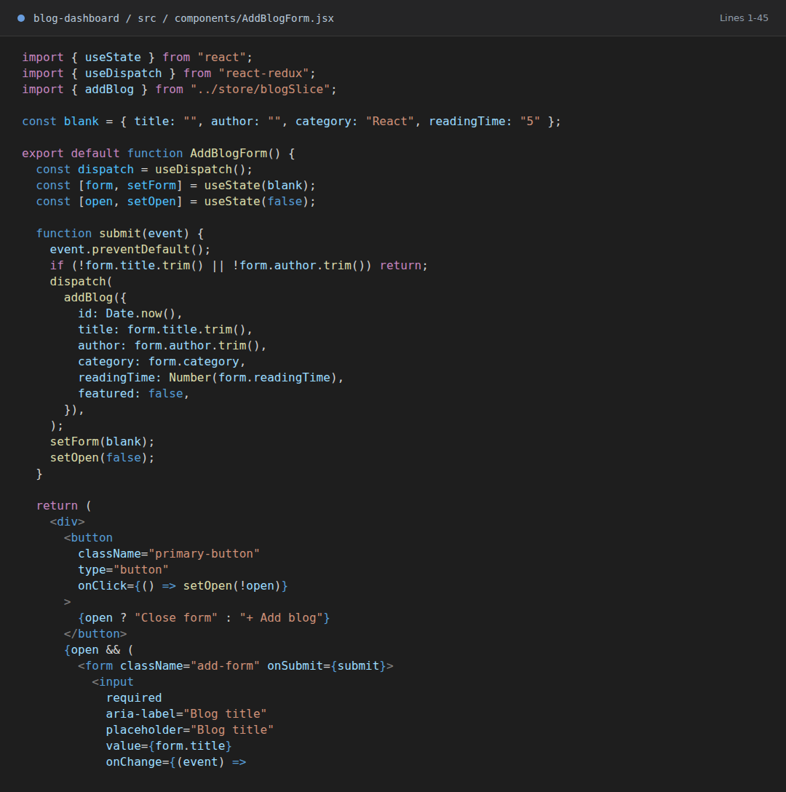
Browser Output after Adding a Blog
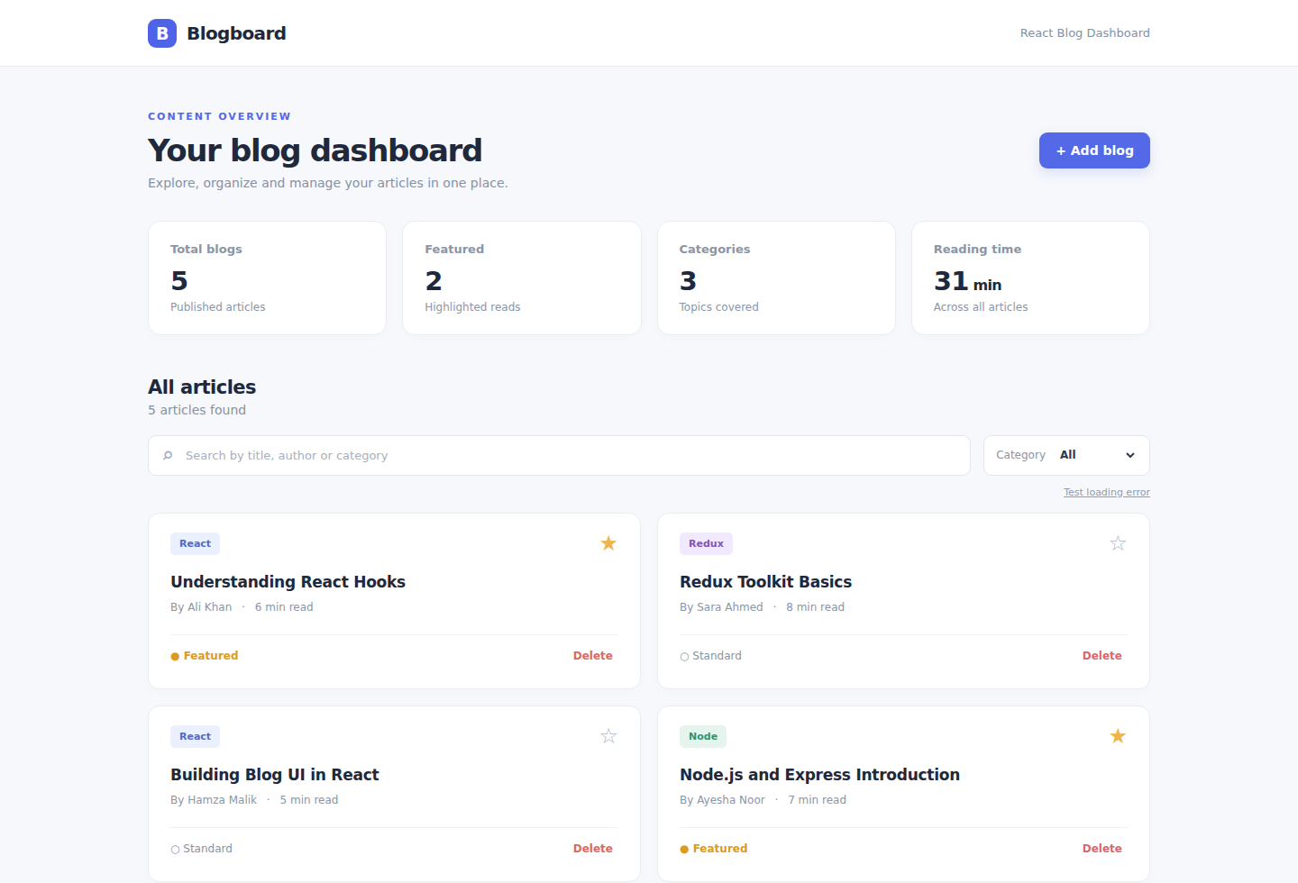

Part 4 Redux Hooks in React Components Marks 1
App reads Redux state through useSelector and dispatches actions through useDispatch. SearchBar and AddBlogForm use the same pattern.
App Rendering State and Dispatching Actions
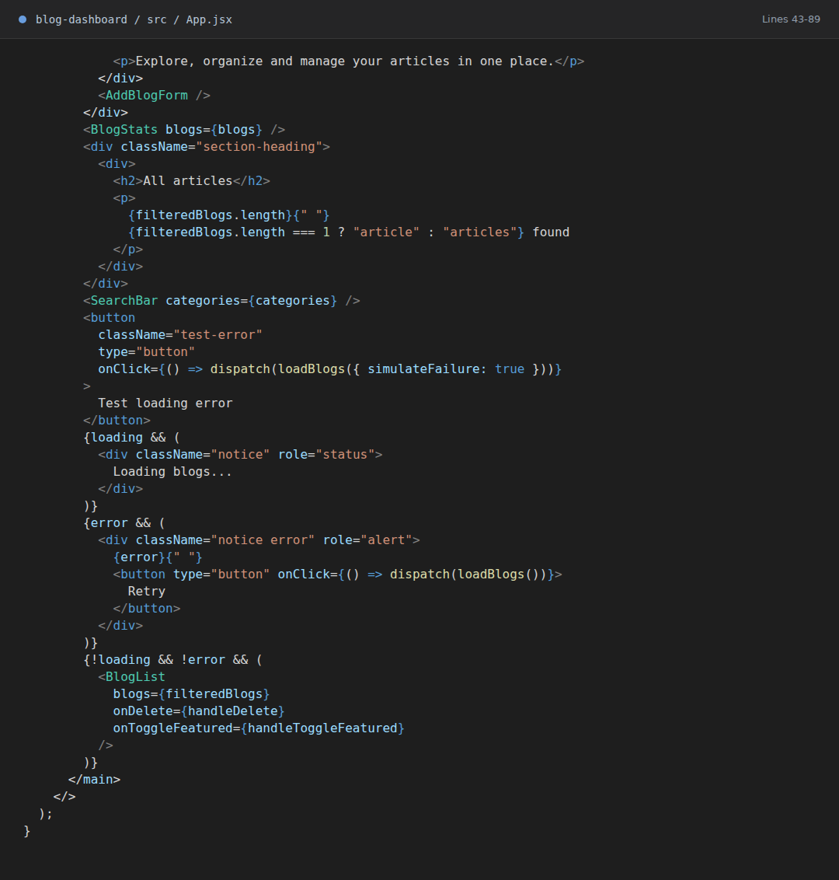
SearchBar Reading and Updating Redux Filters

Part 5 Asynchronous Loading and Error Handling Marks 0.5
loadBlogs is a createAsyncThunk example with a local delayed response and a controlled failure option. The UI displays loading, error, and Retry states.
createAsyncThunk and Rejected Error Message
Browser Output while Loading Blogs
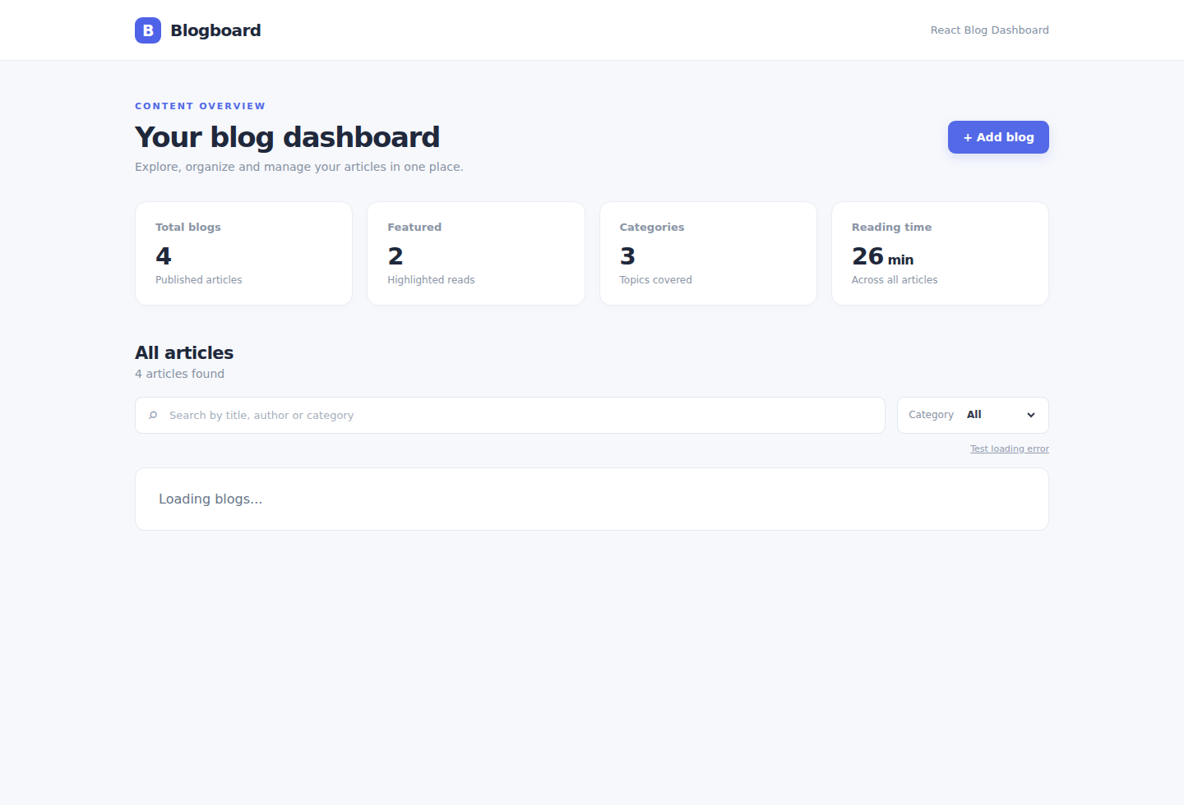
Browser Output with Error and Retry
